Create 3 EC2 instances each for Jenkins, SonarQube and Kubernetes .

Give necessary security group inbound rules to allow SSH on port 22 and allow all traffic from other security groups.

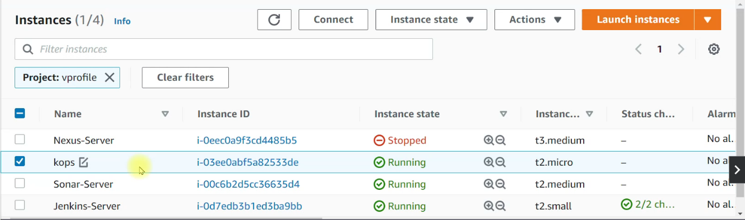

This is the dockerfile

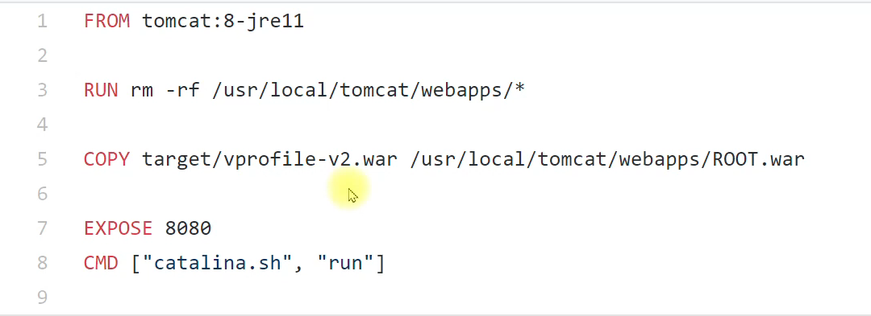

Start Jenkins on the Jenkins-sever instance using git bash to setup ssh connection.

The IP should be the public IP of Jenkins-server instance

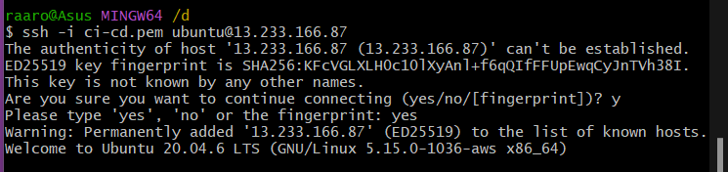

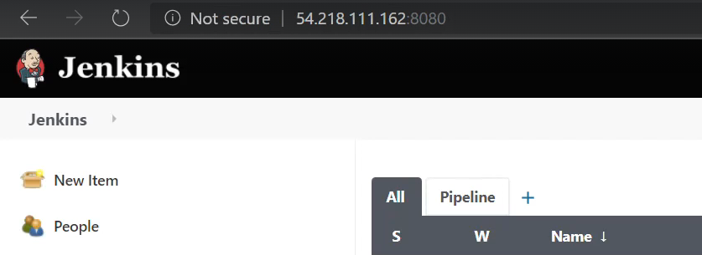

Also start SonarQube on using the public IP of sonar-server instance

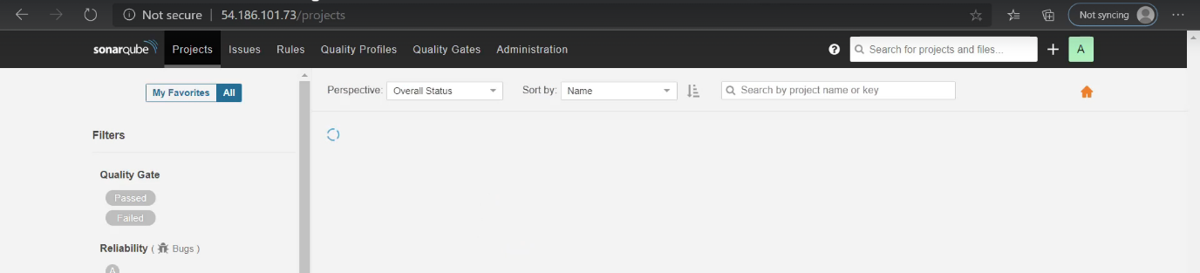

Create a new token in SonarQube in the security section in profile settings.

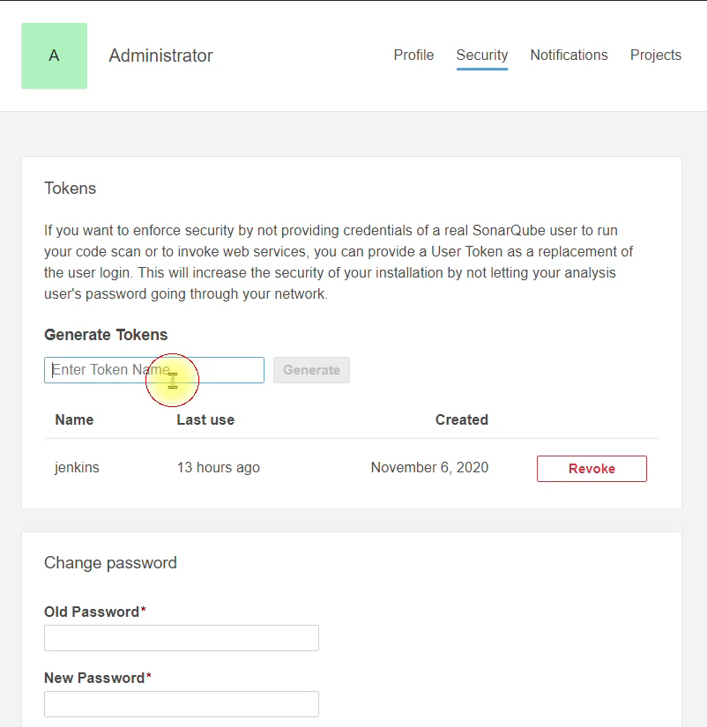

And copy it

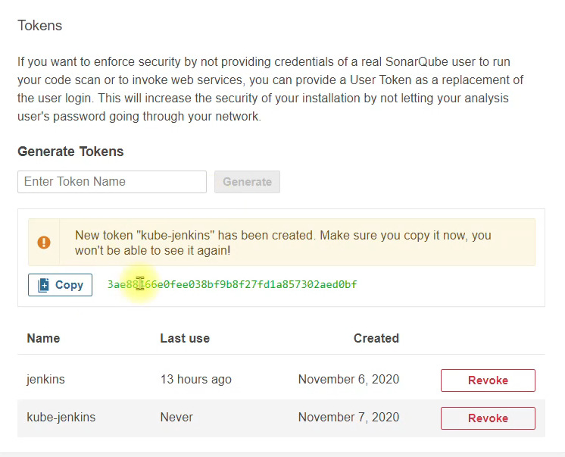

Go to Jenkins> manage Jenkins> system configuration > configure system

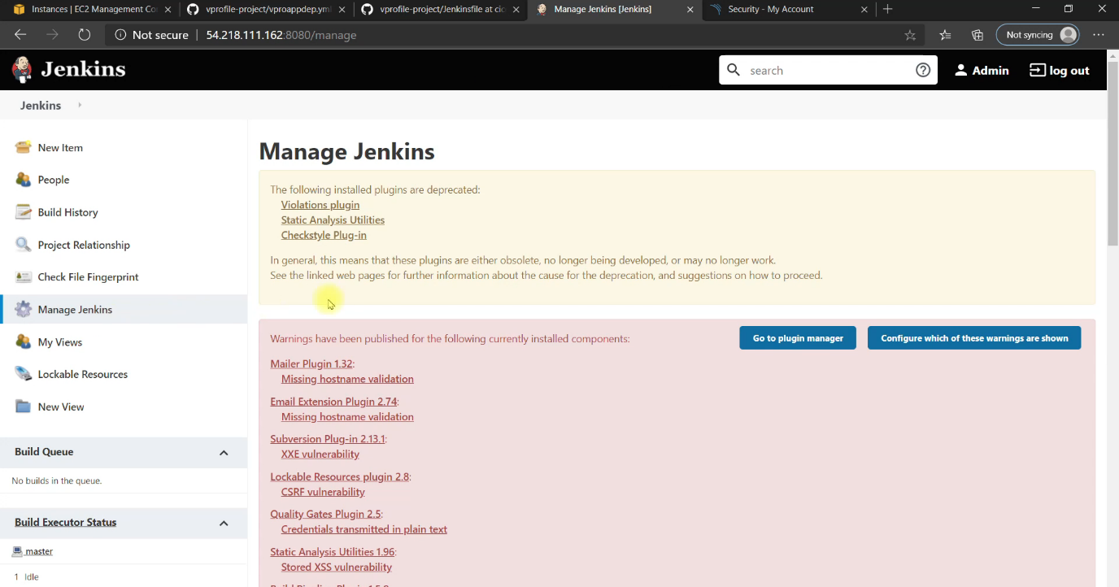

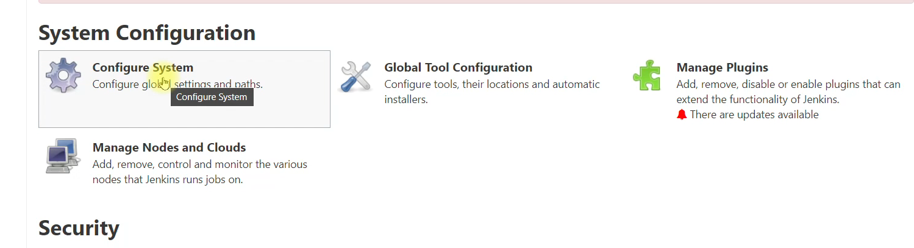

Create a new environment variable in the SonarQube server option

The server url will be “http://private_ip_of_sonar-server”

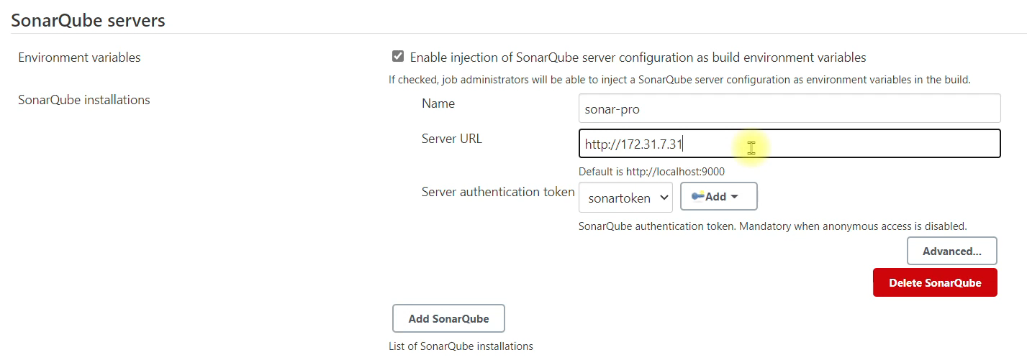

Add a new server authentication token

Secret will be the SonarQube token that was copied

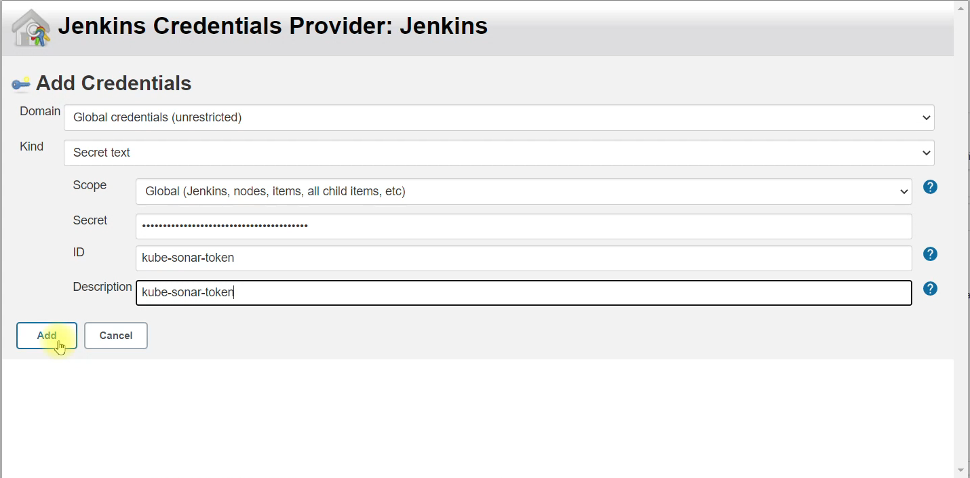

Select the newly created server authentication token

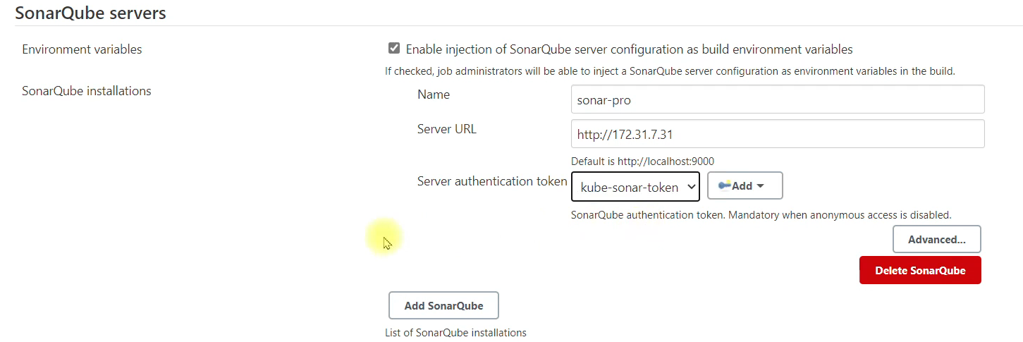

#### Make sure that Jenkins security group allows connection from sonar security group and vice versa####

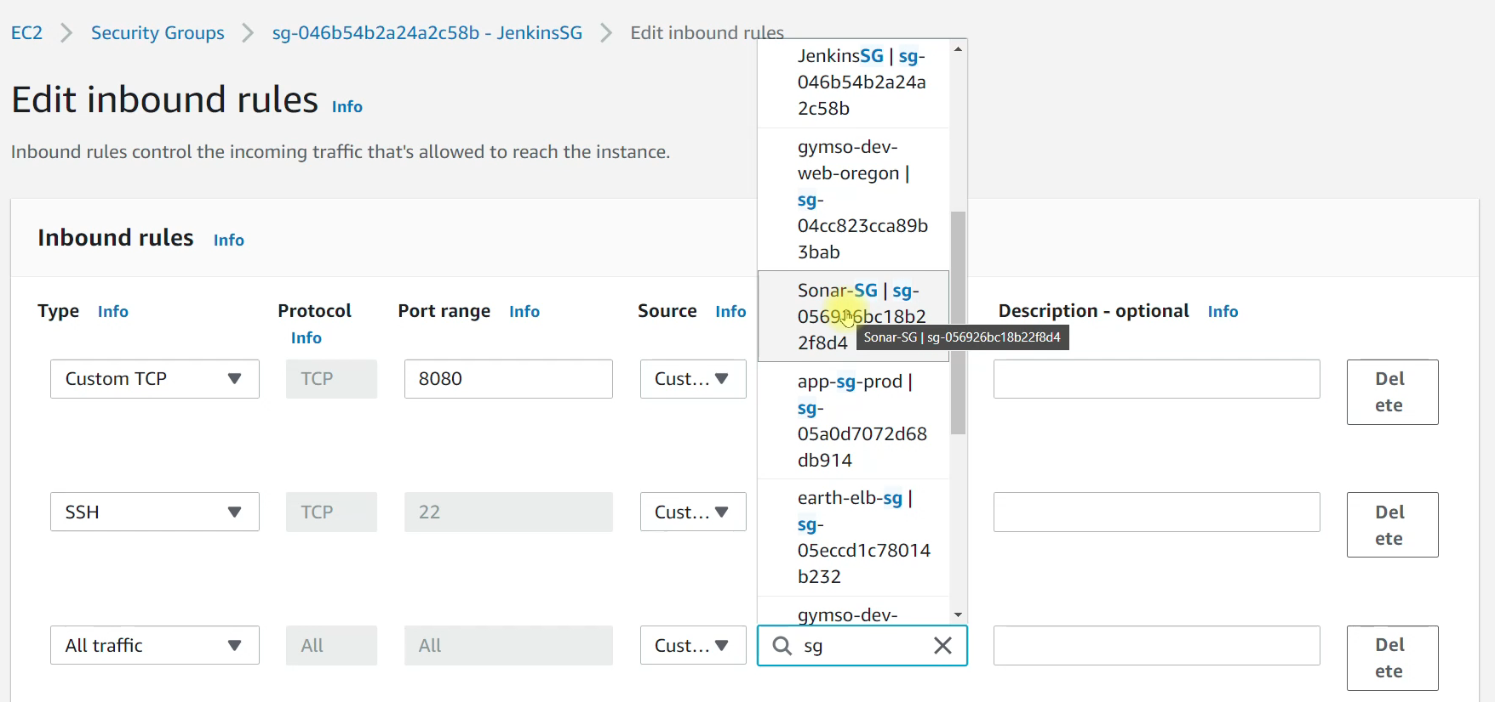

Create new global credentials of dockerhub in Jenkins

And give the id and description as that in Jenkins file

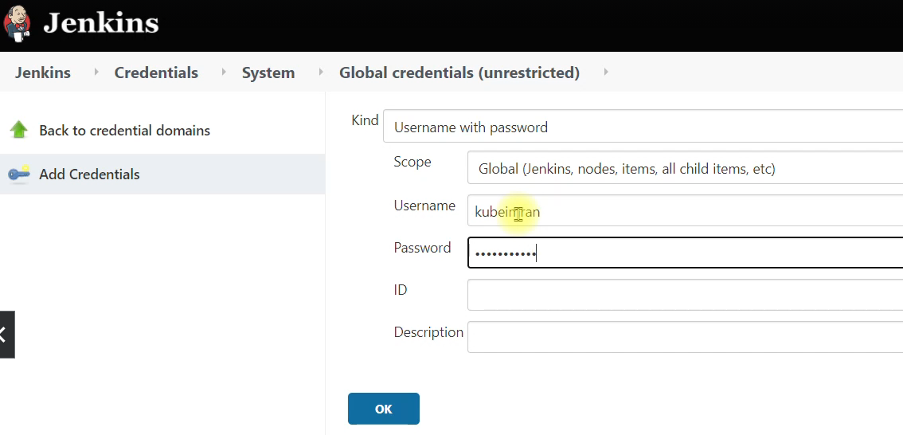

Now we have to install docker in the Jenkins-server instance

So open git bash and start ssh connection

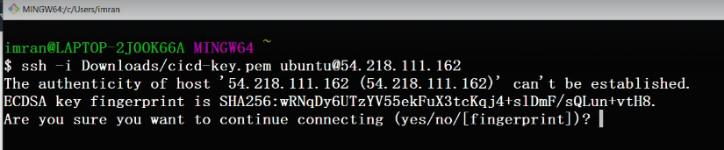

We will be using the docker documentation to install docker in the Jenkins-server instance

[Install Docker Engine on Ubuntu | Docker Docs](https://docs.docker.com/engine/install/ubuntu/)

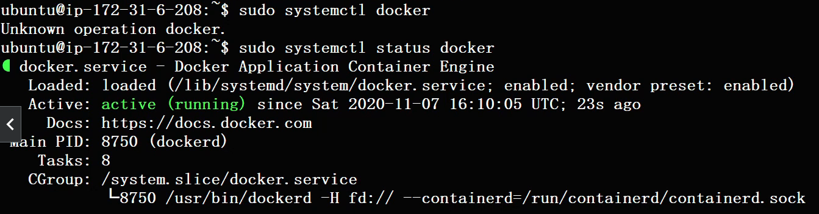

Reason to install docker on Jenkins server is because we are going to run docker build commands on Jenkins.

Till this point only root user or any user that’s a part of docker group can run docker commands, so we are going to add Jenkins user to docker group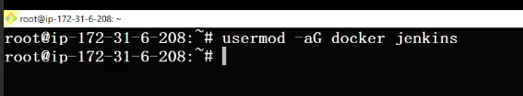

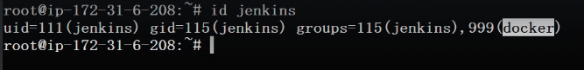

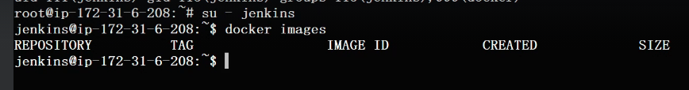

Now we have to restart the Jenkins server to integrate docker to Jenkins process which is already running.

We can restart a Jenkins service if that also don't solve the purpose, you can just reboot the Jenkins.

Refresh the Jenkins page.

Next, we'll create the Kubernetes cluster from cops.

before that, let's install a few plugins.

Search and put a checkmark on all these three plugins, Docker Pipeline, Docker and pipeline utility steps and install without a restart. 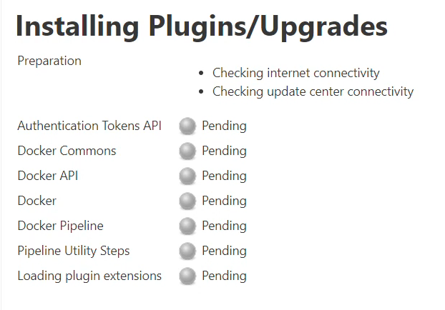

Log in to the kops ec2 instance we're going to create Kubernetes cluster.

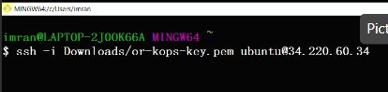 Use the kops instance public ip

Use the command to create the k8s cluster



Zones will be according to the region you’re running the instances in.

Run the kops update cluster command to actually create the cluster



We will install Helme in this kops ec2, for instance using the helm documentation.

[Helm | Installing Helm](https://helm.sh/docs/intro/install/)

We are going to add the kops ec2 instance as a slave to Jenkins and will run Helm command from kops itself. Helm basically is a packaging system for definition files.

Instead of managing all the definition file for deployment service volumes, all the different definition file, we maintain and manage separately. Instead of that, we can use Helm to package all of them and run them or update them on Kubernetes cluster. So, it is Helm that helps you manage Kubernetes Application - Helm Charts. Charts are actually the collection of our definition files, so we can define everything by using charts.

Move the helm directory

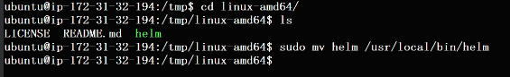

Check if we can access helm using “helm –help”

So we have this set up now. We are going to prepare our repository with all the data.We'll create charts in that. We'll have the Docker file and the Jenkins file.

Before that, let's check whether we have our Kubernetes cluster is up or not.

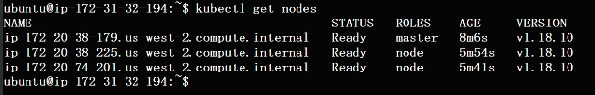

Create new github repo

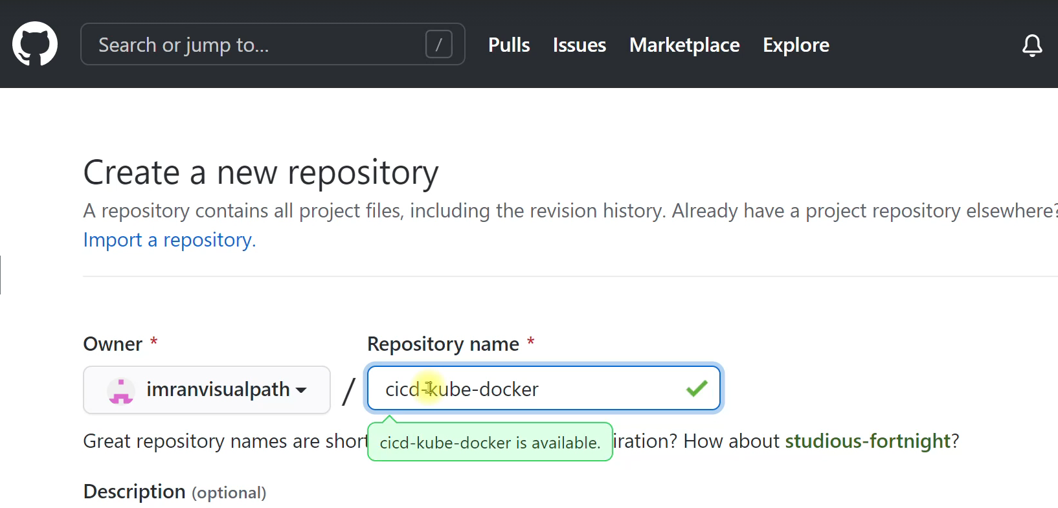

Copy https url and clone it



Also clone the source code repo from “https://github.com/devopshydclub/vprofile-project.git”

Get into our source code repository and we're going to switch to branch VP-docker.

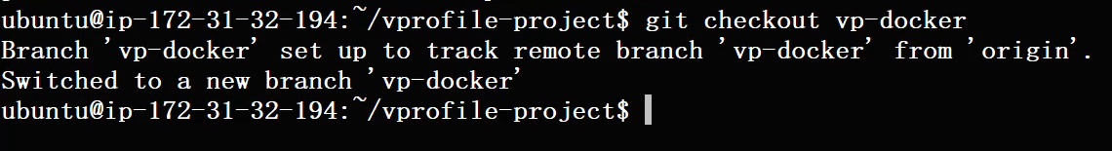

Copy all the data in that branch to our cicd-kube-docker repo

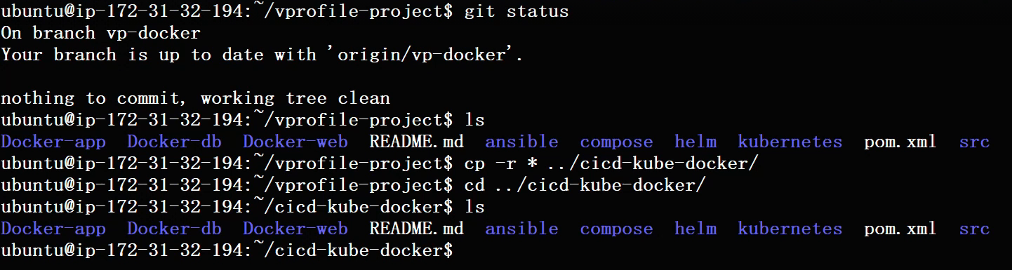

So here we don't need the Docker hyphen db Docker hyphen web. We don't need compose. We don't need Ansible.



In Docker-app directory. You should have the Docker file to build our application image. Let's copy it, move it to the main directory, the top level directory of the repository. So you should have docker file here and then if you want, you can remove docker hyphen app directory.

Remove the helm dir also as we are going to prepare our own.

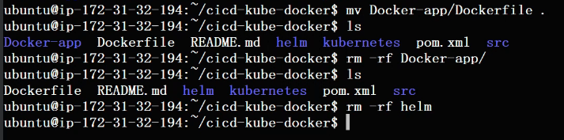

Dockerfile, kubernetes templates

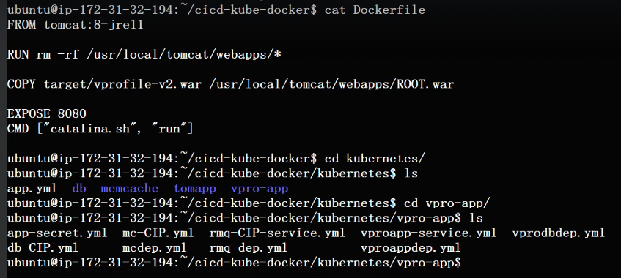

Now in the cicd-kube-docker dir create a new dir by name ‘helm’ and run the command to create helm charts. Name of chart will be the same as mentioned in jenkinsfile

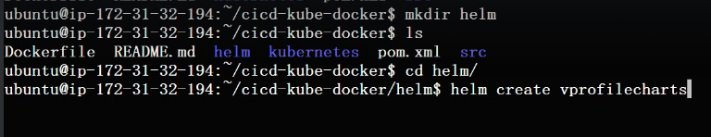

This will create some sample templates and we will be removing all those

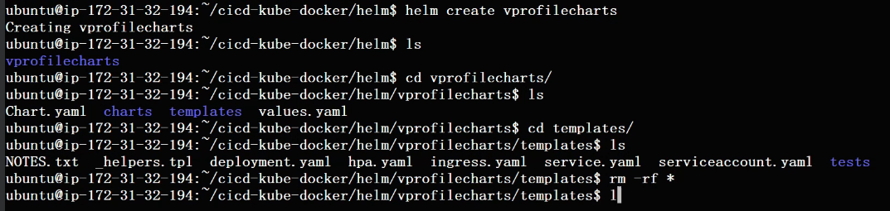

Here we are going to put our definition templates

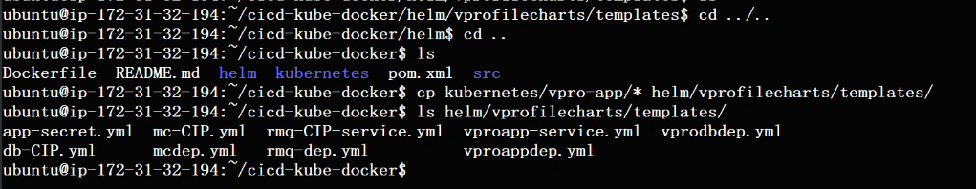

The docker image we are going to build and deploy regularly will be our application

“vim vpoappdep.yml” will be the application yaml

Here we are mentioning the image, and this is the image that will be building it regularly and deploying it so there cannot be a static value. We need to give a variable over here which will pass automatically through Jenkins.

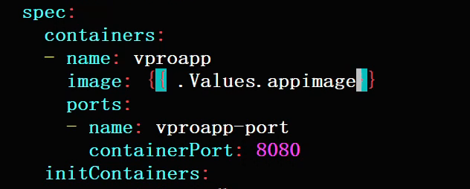

give the variable name as app image. So when we run help command, we're going to pass the value of our app image. So it will have the latest image name and the latest tag.

## There are so many places where we can where you can mention the variables like the labels, port number, the port name, container name.

Now, its time to check the health of helm charts. Ad to do that we have to create a different namespace

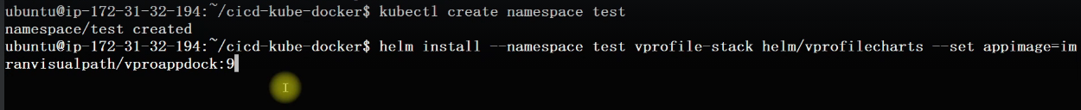

helm install is the command to create the charts and run it

vprofile-stack is the name of the charts. And we have to pass the value to appimage as the dockerhub application image

to check the created charts



And using “kubectl get all –namespace test” we will get all the running pods, service deployment and replica sets.

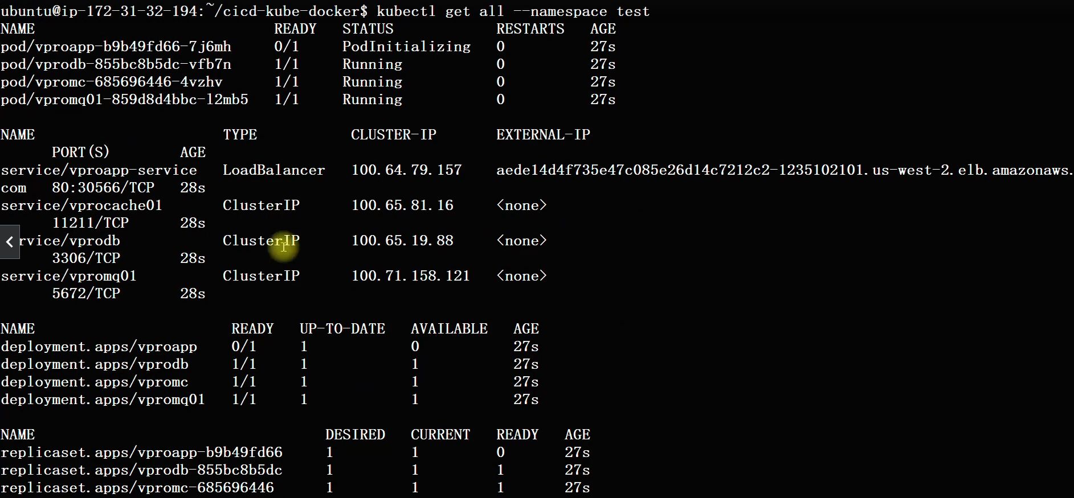

So the complete stack deployment by using one simple command helm install.

So now we will delete it.

We don't need it.

We just want to test it.



We'll also create one more namespace now, which we're going to use from Jenkins.

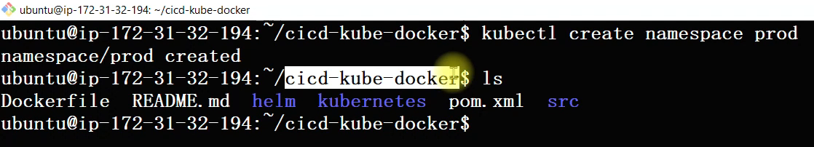

Next, we're going to write Jenkins file. We're going to do it on our system.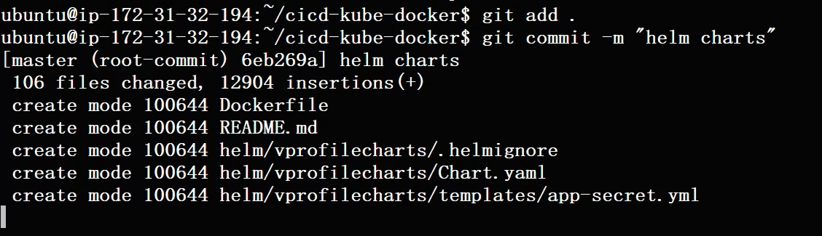

Push all the changes to github repository

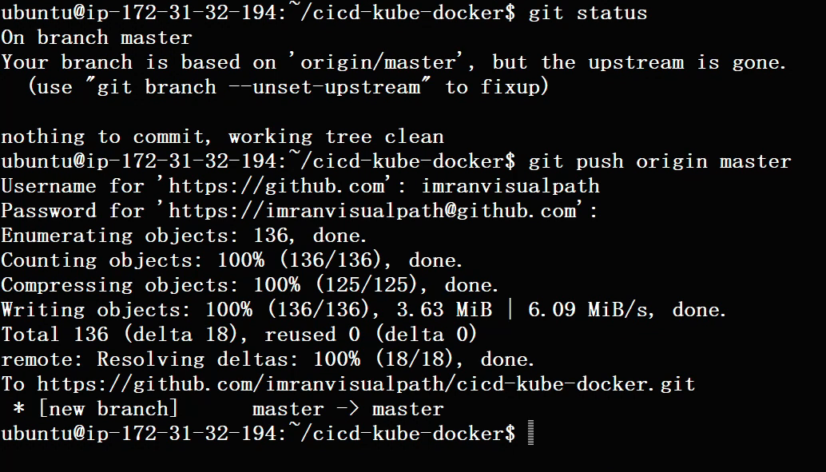

We have to do one last thing. We have to create a Jenkins file in this repository. And then we'll run that Jenkins file from kops.

From Jenkins, we're going to have Jenkins pipeline as a code. So, we'll do that next.

Open IntelliJ and create a new repo as project from version control and give the url as your cicd-kube-docker repo.

Create a new file named as Jenkinsfile in the src directory.

Copy the Jenkinsfile text from <https://github.com/devopshydclub/vprofile-project.git> in the paac branch. Copy the entire file and paste it in the local Jenkinsfile and here we will be making changes.

1. Remove line 85 to 121
2. Define new variablesas registery=”dockerhub_acc/image”
3. And registeryCredentials=’dockerhub’ (same as the one given in Jenkins) 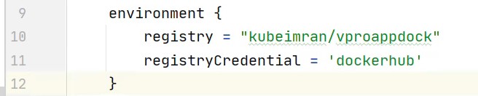
4. Remove line 16 to 19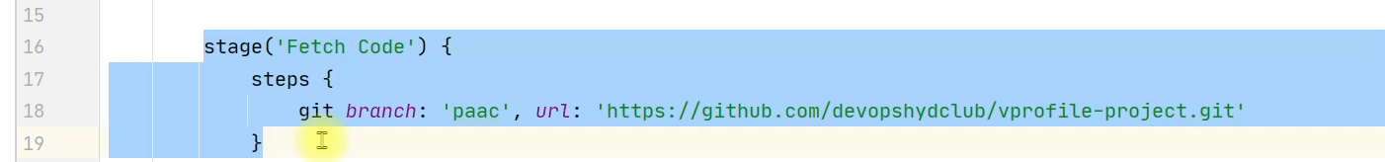
5. Create a new stage to build the image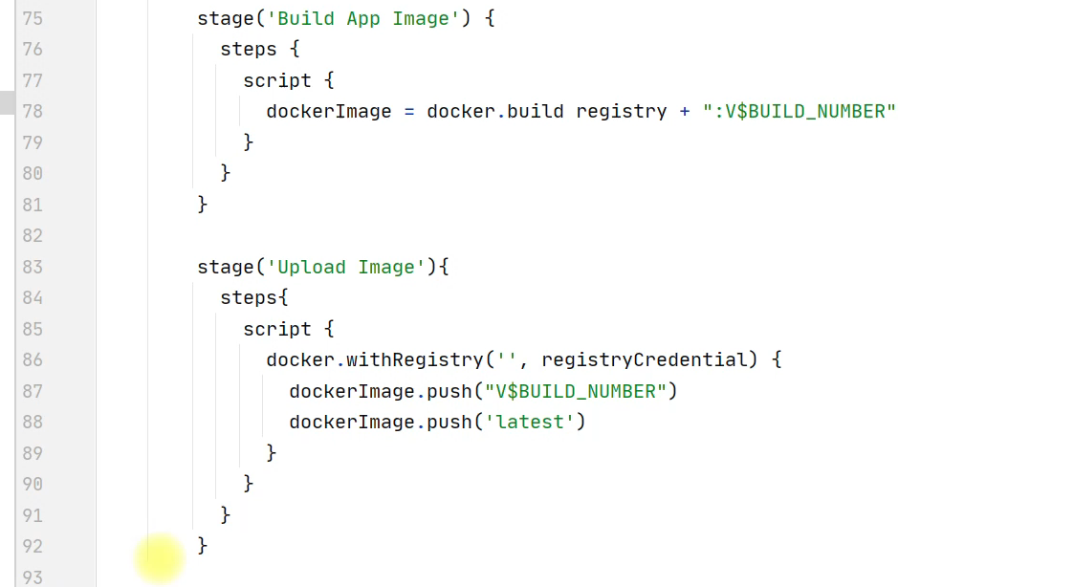
6. 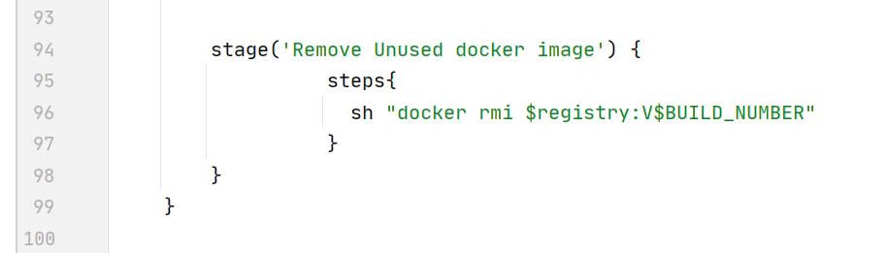

Get into kops ec2 instance

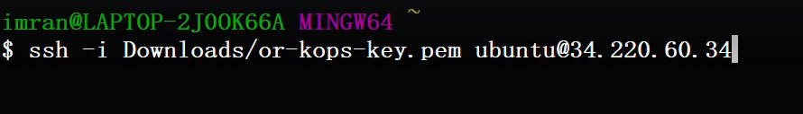

We need a JDK so we can add Jenkins or we can add the kops VM as a slave to Jenkins master.

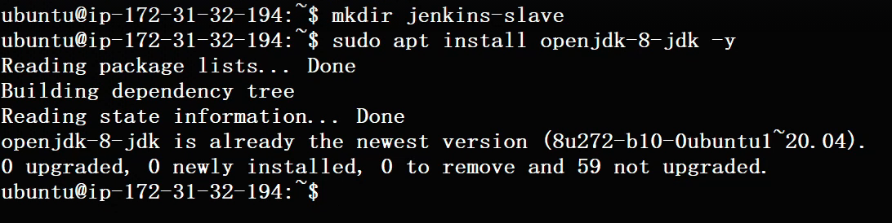

And then we also need to change ownership of ubuntu user for Jenkins to access the slaves

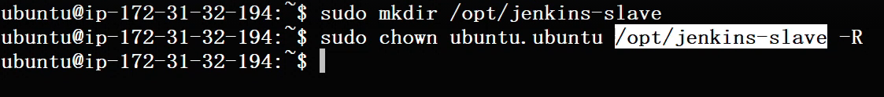

So Jenkins master will keep its agent and workspace in this directory. And we're going to use ssh from Jenkins to log in to this kops ec2 instance with a ubuntu user. So ubuntu uer should own this directory.

Before we add the slave we have to update the kops security group. As Jenkins is going to do ssh to the kops instance.

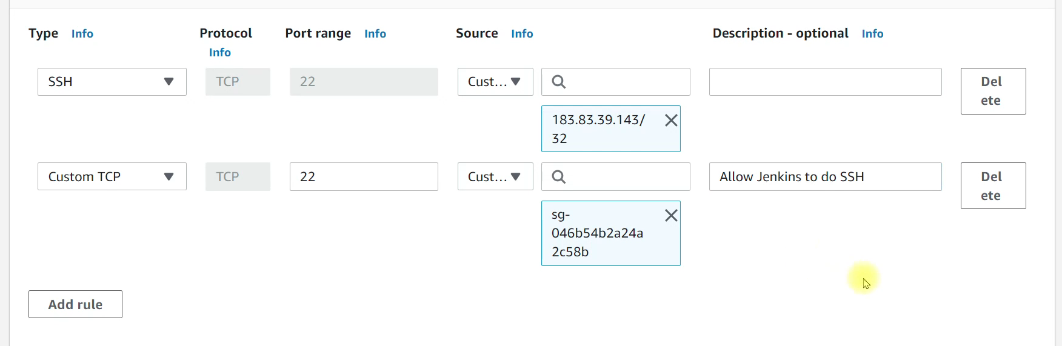

Jenkins sg

Now we can add it as a slave.

Go to Manager Jenkins. Manage nodes and clouds. Let's add a new node.

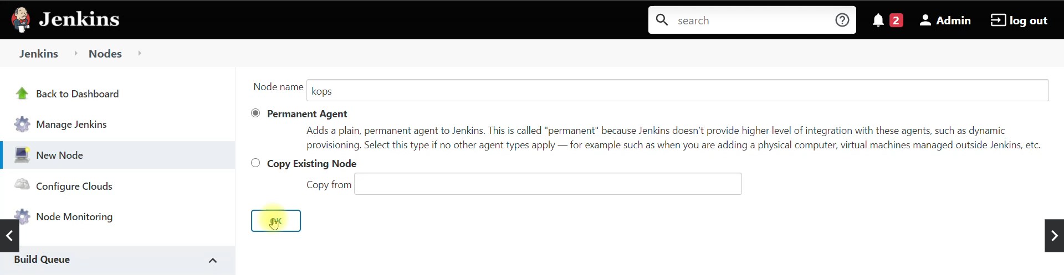

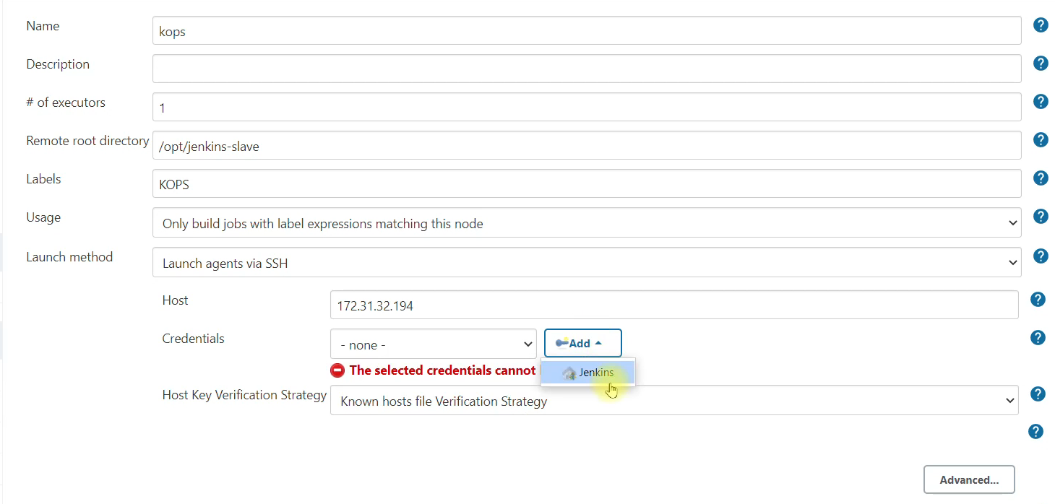

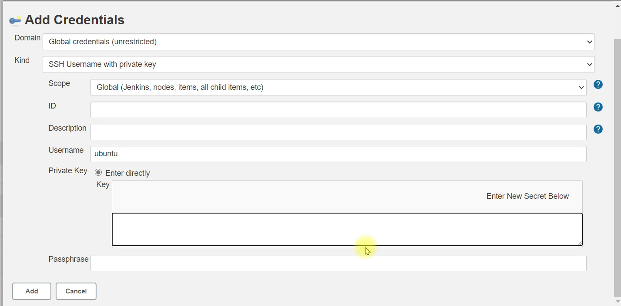

Logout from kops instance and copy contents of kops pem file and paste it in the key value box

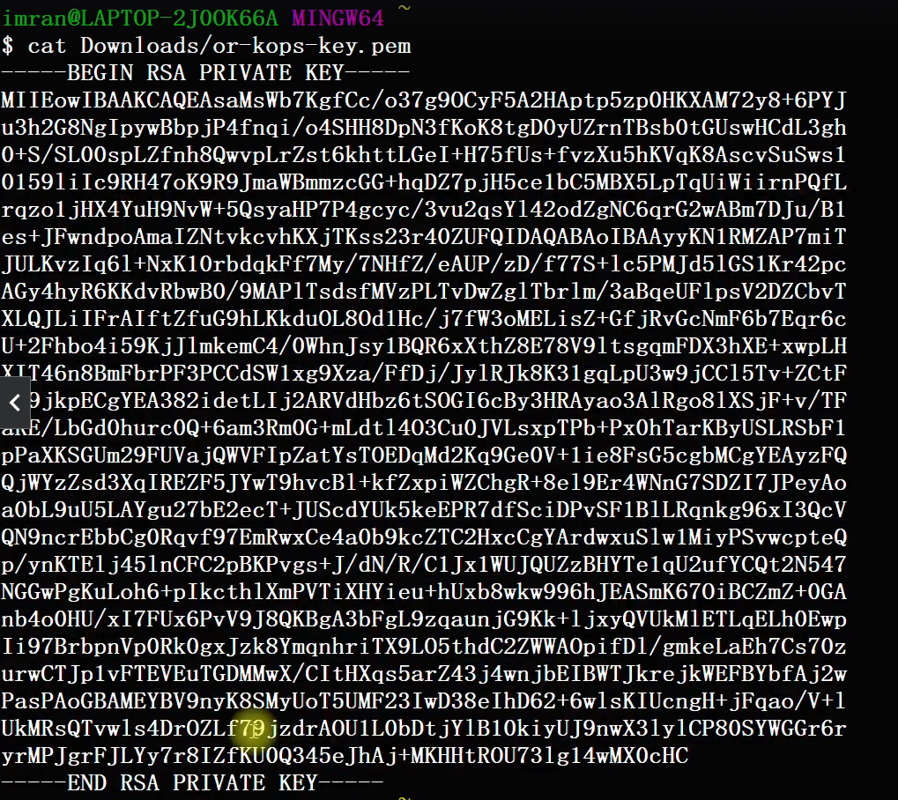

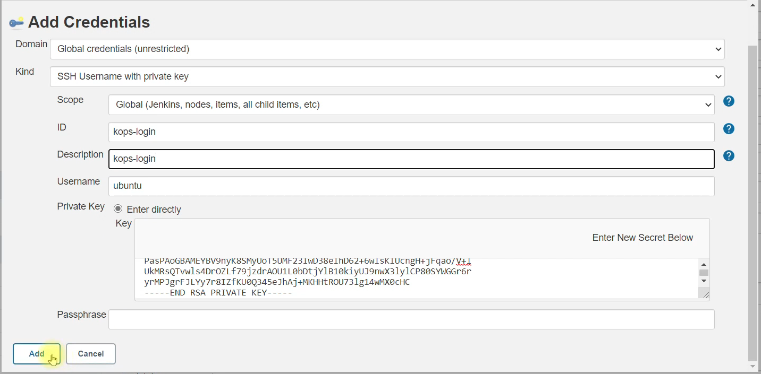

Select the credentials as ubuntu(kops-login)

And non verifying host key verification strategy, so it doesn’t ask any question for ssh.

And save and relaunch agent.

We're going to run helm command from here. We already have tested the helm command from our kops ec2 instance.

So in Jenkinsfile

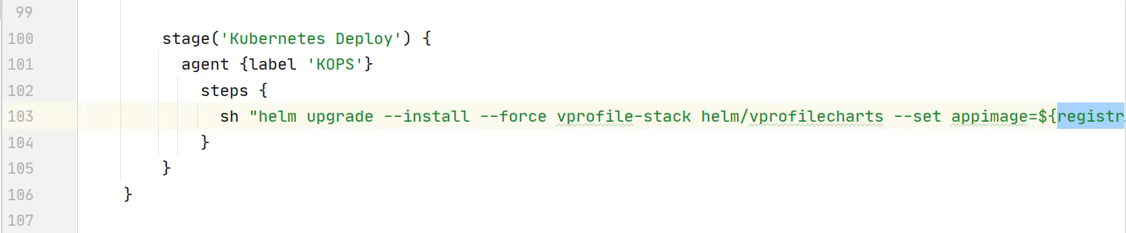

Command continued

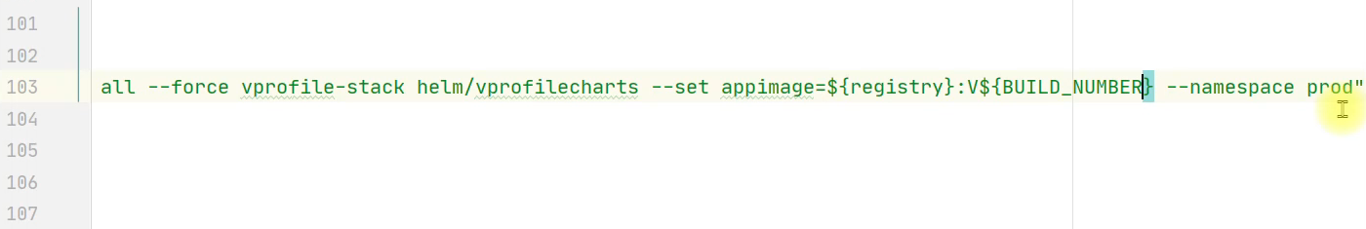

Save and commit with message, and push.

Go to Jenkins> manage Jenkins > global tool configuration> SonarQube scanner.

Same name as in Jenkinsfile

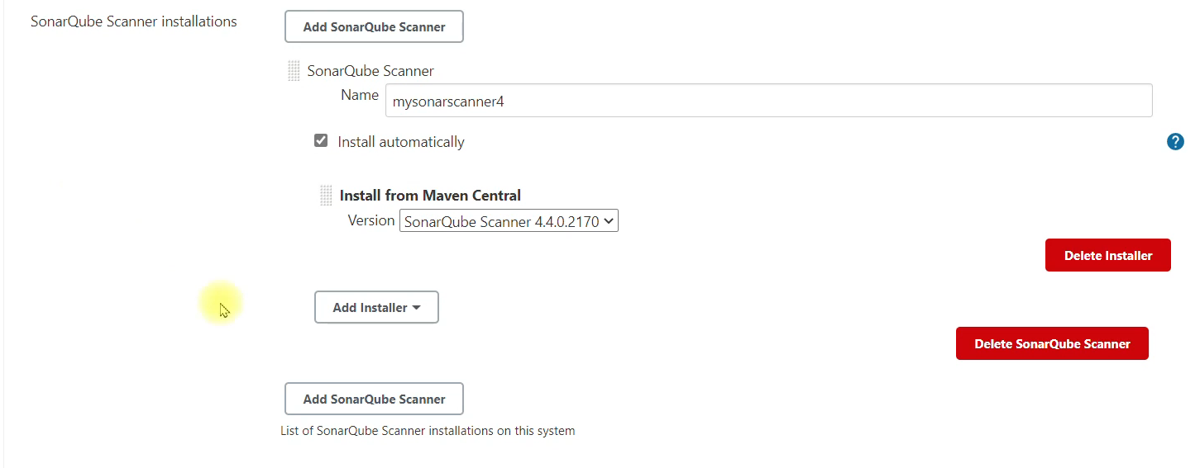

####################### EXECUTION #################

Create a new job in Jenkins, name = kube-cicd-pipeline, select pipeline

Select pipeline script from SCM, select SCM as Git and give url of cicd-kube-docker repo.

Save and build now

There seems to be some failure at SonarQube level, go to console output and in the end 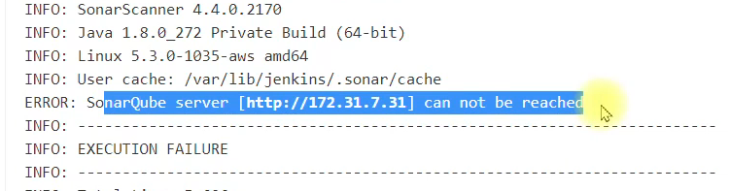

In sonar security group. Allow all traffic from Jenkins security group

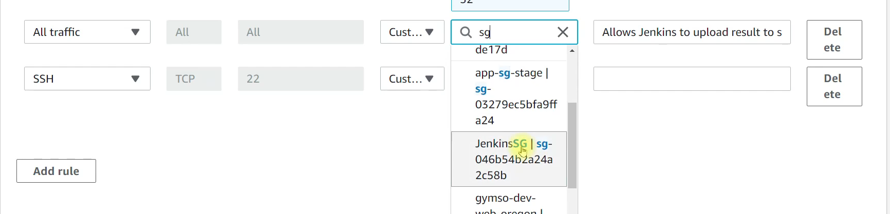

Now run the job once again

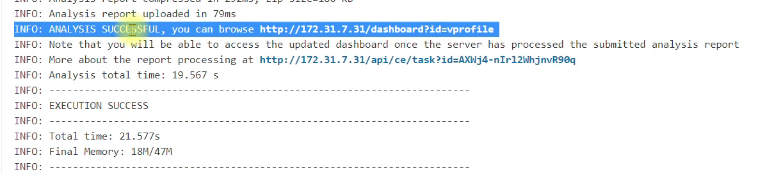

Analysis was successful, it should have uploaded everything to SonarQube server

Attach quality gates to the project

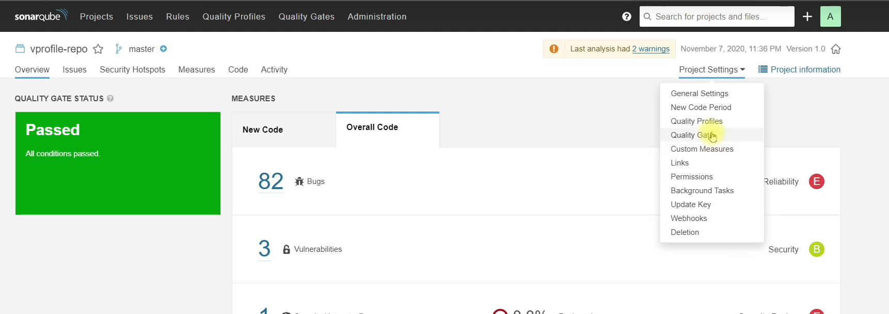

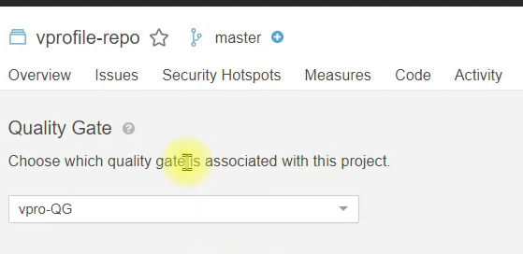

We need to setup the webhook

So Jenkins is waiting for a sonar cube to respond back with the quality gate status. Sonar Cube has no idea about where is Jenkins. We need to do this in pipeline as a code.

SonarQube Project > Project Settings > Web Hooks.

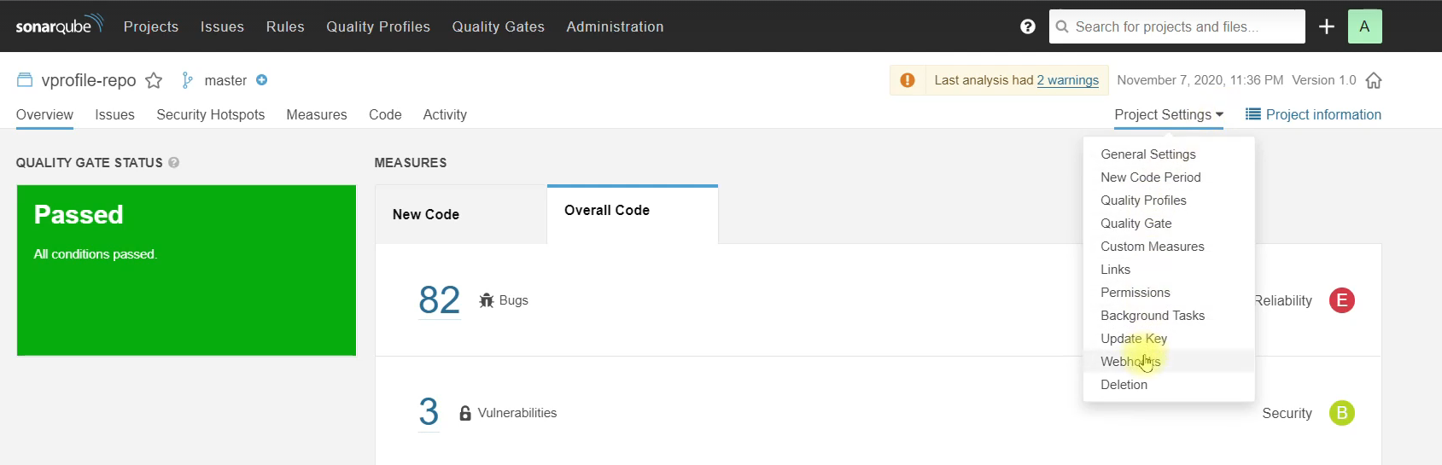

Create new webhook (ip will be private ip of jenkins ec2)

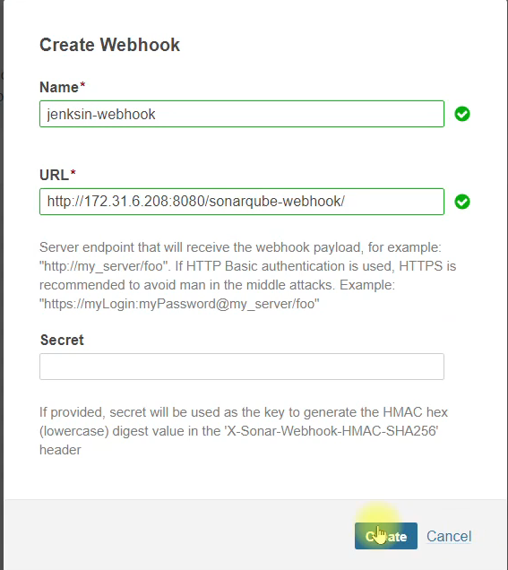

Build again

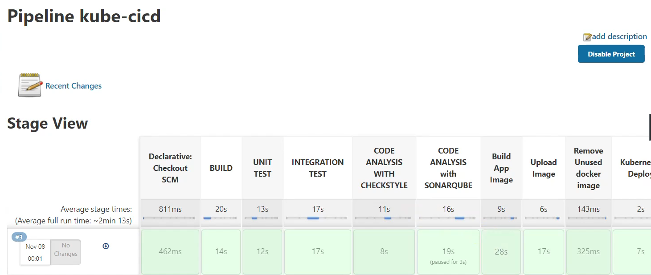

SUCCESSFUL🎉🎉